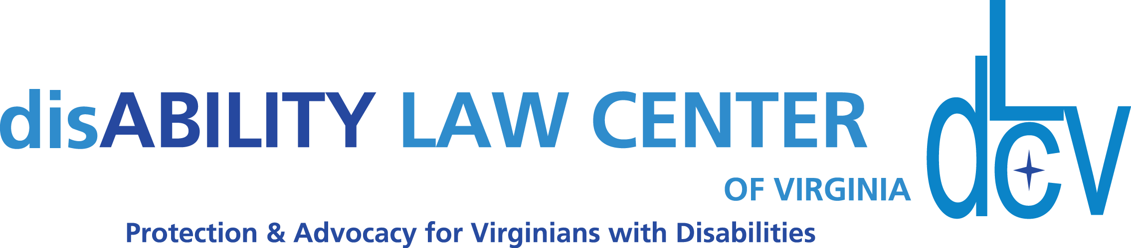

1512 Willow Lawn Dr. Ste. 100, Richmond, VA 23230 T:800-552-3962 www.dLCV.org F:804-662-7431

Darrel Tillar Mason “Excellence in Advocacy” Award Nomination Form

E-mail this form or this information in a document to specialevents@dlcv.org by May 31, 2022.

Name of Nominee: Click here to enter text.

Phone: Click here to enter text. Email: Click here to enter text.

Current employment or volunteer activity: Click here to enter text.
Time frame of nominee’s advocacy efforts: Click here to enter text.

Description of nominee’s accomplishments – What is it that makes this nominee special? What has this person done to promote inclusion of people with disabilities in the arts? See the attached qualifications description. Use additional pages if needed, but please limit your entire submission to five pages.

Explanation of context in which accomplishments occurred (e.g. job, volunteer, elected official):

Other supportive information (e.g. resume, C.V., letters of support, newspaper article, image, program) can be submitted along with this form, but please limit the total submission to five pages.

If your nominee is selected, are you able to attend our Midsummer Night’s Gala on Friday, June 18, at the Glen Allen Cultural Arts Center? ☐ YES ☐ NO
Your Name (Nominator): Click here to enter text.

Your Phone: Click here to enter text. Your Email: Click here to enter text.

Your Connection to Nominee: Click here to enter text.

Your Signature (electronic is fine):_________________________ Date: Click here to enter text.

